

Team 14

Elaboration Document

CheckPoint

Team Members:

|  |
| --- |
| 216442656, Claire Bodley  217143903, Carmel Chan-Lok  217103413, Kristin Giddy  217257968, James Shepherd |

Document Due Date: 20 June 2019

**TABLE OF CONTENTS**

1 FUNCTIONAL REQUIREMENTS 3

1.1 Analysis Use Case Model 3

1.2 Use Case Glossary and Responsibilities 4

2 UI Prototypes 6

2.1 Team UI Guidelines 6

2.2 UI Designs & Updated Analysis Use Case Narratives 7

2.2.1 Designed by Carmel Chan-Lok 9

2.2.2 Designed by Kristin Giddy 17

2.2.3 Designed by Claire Bodley 26

2.2.4 Designed by James Shepherd 31

3 DATA REQUIREMENTS 37

3.1 Domain Class Diagram 37

3.2 Implementation Ready Class Diagram 38

# FUNCTIONAL REQUIREMENTS

## Analysis Use Case Model

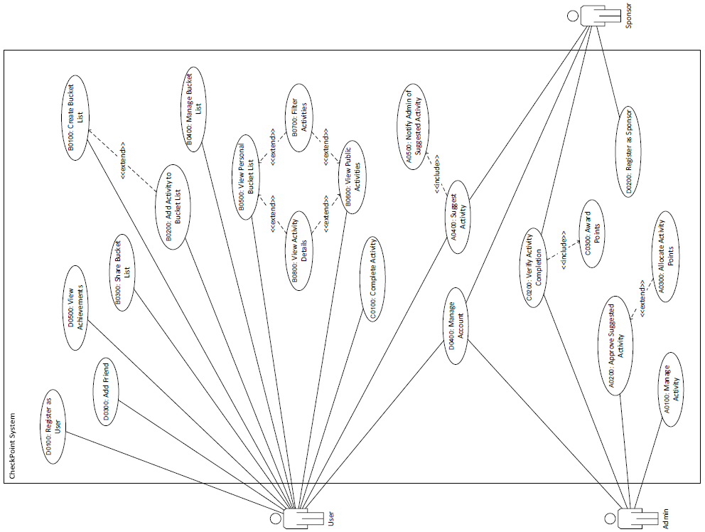

## Use Case Glossary and Responsibilities

|  |  |
| --- | --- |
| **Team Member Responsible: Carmel Chan-Lok** | |
| **Use Case Id** | **Use Case Name** |
| A0100 | Manage Activity |
| A0200 | Approve Suggested Activity |
| A0300 | Allocate Activity Points |
| A0400 | Suggest Activity |
| A0500 | Notify Admin of Suggested Activity |
| **Queries/Reports** | |
| B0600 | View Public Activities |

|  |  |
| --- | --- |
| **Team Member Responsible: Kristin Giddy** | |
| **Use Case Id** | **Use Case Name** |
| B0100 | Create Bucket List |
| B0200 | Add Activity to Bucket List |
| B0300 | Share Bucket List |
| B0400 | Manage Bucket List |
| **Queries/Reports** | |
| B0700 | Filter Activities |

|  |  |
| --- | --- |
| **Team Member Responsible: Claire Bodley** | |
| **Use Case Id** | **Use Case Name** |
| C0100 | Complete Activity |
| C0200 | Verify Activity Completion |
| C0300 | Award Points |
| **Queries/Reports** | |
| B0500 | View Personal Bucket List |
| B0800 | View Activity Details |

|  |  |
| --- | --- |
| **Team Member Responsible: James Shepherd** | |
| **Use Case Id** | **Use Case Name** |
| D0100 | Register as User |
| D0200 | Register as Sponsor |
| D0300 | Add Friend |
| D0400 | Manage Account |
| **Queries/Reports** | |
| D0500 | View Achievements |

# UI Prototypes

## Team UI Guidelines

Our team decided to implement a simplistic design with a colour scheme centered around yellow. Yellow represents victory and happiness, which is how we want users to feel when they interact with the application.

This colour is featured in the design in two ways: as a bolded, yellow background or as a yellow border. This can be seen with the buttons and other UI controls; where the first is a filled button and the rest have a stroke (border) with a white fill.

Similar data sheet layouts are used when displaying a bucket list and the activities in the bucket list. To view bucket list details or activity details, the user must click the three dots appearing next to each listed item. This is a case of using recognition rather than recall, where we have been careful to use intuitive and recognisable symbols to indicate functionality. We also included settings menus indicated by three horizontal stacked lines, which is a widely recognised menu and drop-down list symbol.

There are two fonts present in this design that are used consistently: Montserrat and Cantrell. The Montserrat is used for the headings and the Cantrell is used for body text.

For confirmation messages or error messages a pop-up box is created following the same design as the rest of the application. This will help with error prevention and provide feedback to assist application use.

We prioritised simplicity in the aesthetics and layout of the GUI design so as to make navigation as easy and intuitive as possible, avoiding convoluted navigation paths and complicated actions. With these elements and designs in place, we were able to create a constant theme throughout the user interface.

## UI Designs & Updated Analysis Use Case Narratives

Basic Screen designs:

Welcome screen: Log in screen:

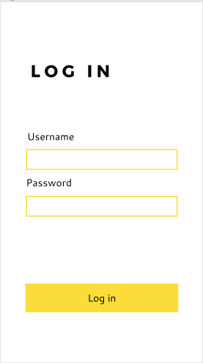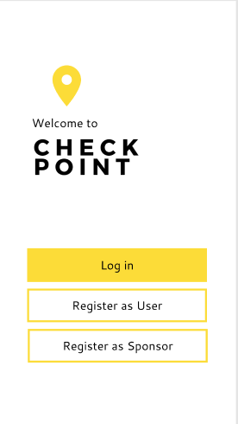

User home page:

Top right drop-down menu is indicated by three horizontal stacked lines. The screen on the right displays options available when menu is selected.

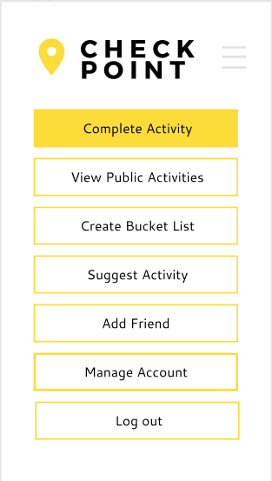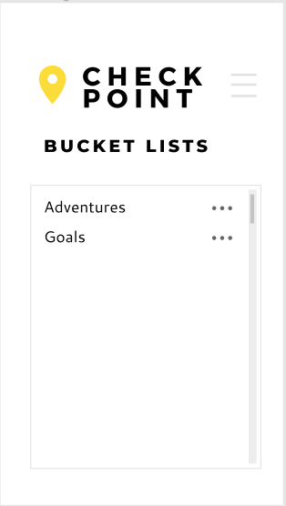

Sponsor home page: Admin home page:

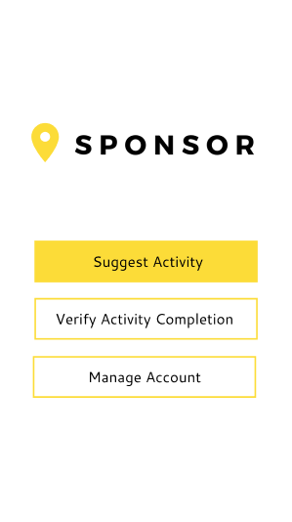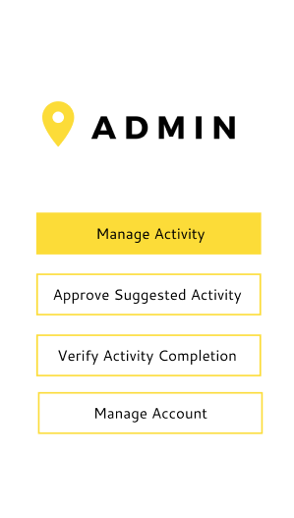

### Designed by Carmel Chan-Lok

|  |  |  |
| --- | --- | --- |
| **Use Case ID** | **Use Case Name** | |
| A0100 | Manage Activity | |
| **Primary Business Actors** | | **Other participating Actors** |
| Admin | |  |
| **Description** | Responsible for creating, updating and deleting activities. | |
| **Pre-Conditions** | The Admin is logged in. | |
| **Triggers** | The Admin selects the “Manage Activity” option within the Admin home page. | |
| **Post-Conditions** | An activity is created, updated or deleted. | |
| **Basic Flow of Events** | 1. Options “Create Activity”, “Update Activity” and “Delete Activity” are displayed. 2. Admin selects “Create Activity”. 3. The system displays an activity details form, with “Cancel” and “Save” buttons available. 4. Admin inputs activity name, along with other details, including a brief description, difficulty level and the number of points to be rewarded if the user completes the activity. 5. Admin selects “Save”. 6. The system saves the activity within the CheckPoint database. 7. A message is displayed confirming that the activity has been saved. Additional activities may be added in the same manner. Admin selects “Cancel”. 8. Admin home screen displayed. | |
| **Alternate Flow of Events** | 2. Admin selects “Update Activity”  3. The system displays a search bar, with “Search” and “Cancel” buttons available.  4. Admin inputs the name of the activity in the search bar.  5. Admin selects “Search”.  5.1. Admin selects “Cancel”  5.2. Return to Basic Flow step 8.  6. The system displays a list of activities containing the searched activity name.  6.1. The system does not find any activities containing the searched activity name and displays “No activities found” message, as well as an “OK” button.  6.2. The Admin selects “OK” and is returned to step 3.  7. Admin selects the required activity.  7.1. Admin selects “Cancel”  7.2. Return to Basic Flow step 8.  8. Return to Basic Flow step 3. | |
| **Alternate Flow of Events** | 2. Admin selects “Delete Activity”.  3. The system displays a search bar, with “Search” and “Cancel” buttons available.  4. Admin inputs the name of the activity in the search bar.  5. Admin selects “Search”.  6. The system displays a list of activities containing the searched activity name.  6.1. The system does not find any activities containing the searched activity name and displays “No activities found” message, as well as an “OK” button.  6.2. The Admin selects “OK” and is returned to step 3.  7. Admin selects the required activity.  7.1. Admin selects “Cancel”.  7.2. Return to Basic Flow step 8.  8. A confirmation message appears for the user to “Confirm” or “Cancel” the deletion.  9. Admin selects “Confirm”.  9.1. Admin selects “Cancel”.  9.2. Return to step 6.  10. A message confirms that the activity has been deleted.  11. Return to Basic Flow step 8. | |
| **Alternate Flow of Events** | 5. Admin selects “Cancel”  6. Return to Basic Flow step 8. | |
| **Initial UI design** | [See below] | |

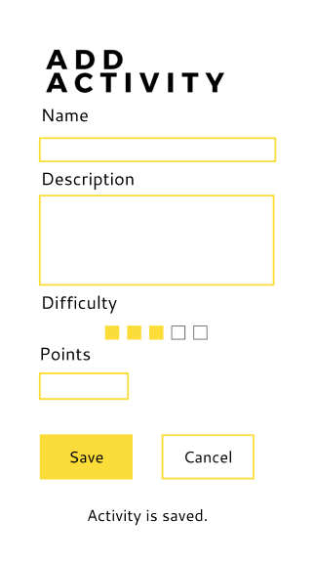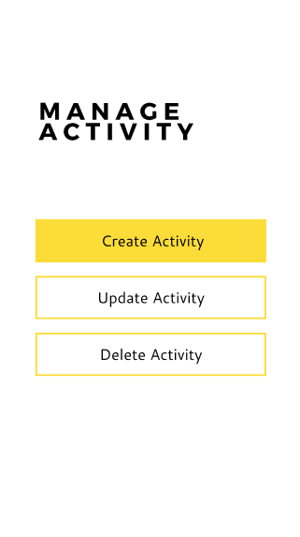

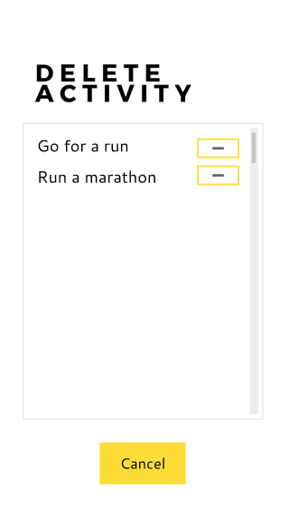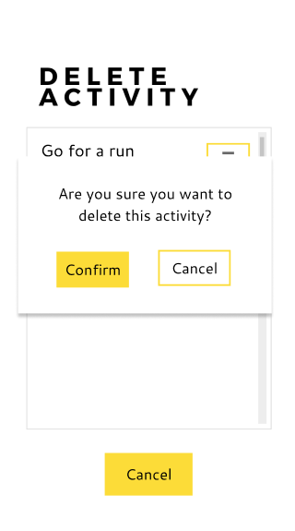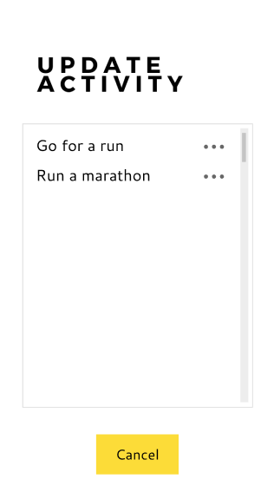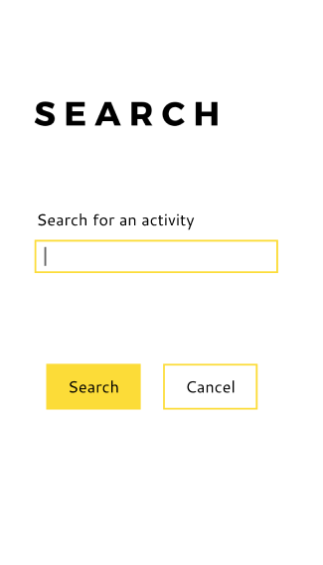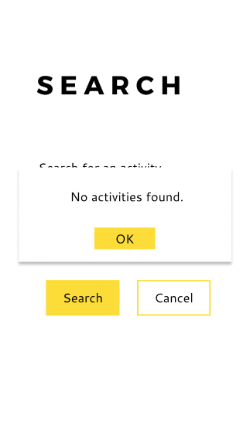

|  |  |  |
| --- | --- | --- |
| **Use Case ID** | **Use Case Name** | |
| A0200 | Approve Suggested Activity | |
| **Primary Business Actors** | | **Other participating Actors** |
| Admin | |  |
| **Description** | The Admin is able to asses an activity suggested by a user/sponsor and approve or reject the activity. In the case of approval, the activity is added to the CheckPoint system’s database. boolean variable that states true/false to show whether or not activity approved | |
| **Pre-Conditions** | The Admin is logged in. The Admin has received notification of the activity suggestion. | |
| **Triggers** | The Admin selects the “Approve Suggested Activities” option within the Admin home page. | |
| **Post-Conditions** | The activity is either added to the CheckPoint database or rejected. The user/sponsor who sent the request is notified of the outcome. | |
| **Basic Flow of Events** | 1. The system displays a list of the activities that require approval, with “Approve”/(Tick) or “Reject”/(Cross) buttons alongside each activity, as well as a “Back” option. 2. The Admin selects “Approve” on an activity. 3. Calls A0300. 4. The system displays an activity confirmation message, as well as buttons “Save” and “Cancel”. 5. Admin selects “Save”. 6. The system adds the suggested activity to the CheckPoint database. 7. A message is displayed confirming that the suggested activity has been saved. The user/sponsor is notified of the approval of their suggested activity. 8. Return to step 1. | |
| **Alternate Flow of Events** | 2. The Admin selects “Reject” on an activity.  3. A message is displayed confirming the rejection of the suggested activity, as well as “Confirm” and “Cancel” buttons.  4. The Admin selects “Confirm”  4.1. The Admin selects “Cancel”  4.2. Return to Basic Flow step 1.  5. The system deletes the activity suggestion from the list. The user/sponsor is notified of the rejection of their suggested activity.  6. Return to Basic Flow step 1. | |
| **Alternate Flow of Events** | 2. The Admin selects “Back”.  3. Home page displayed. | |
| **Alternate Flow of Events** | 5. Admin selects “Cancel”.  6. Return to Basic Flow step 1. | |
| **Initial UI design** | [See below] | |

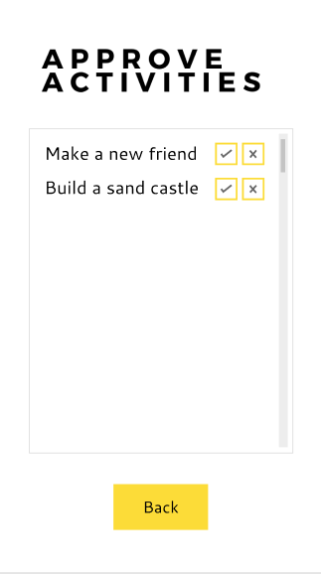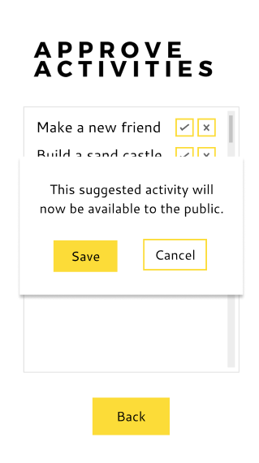

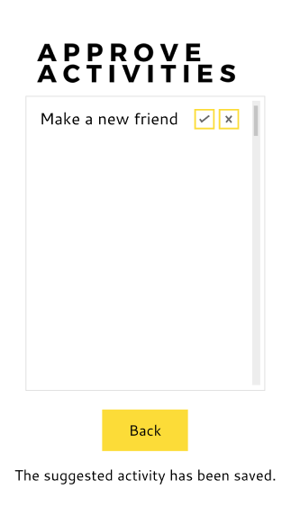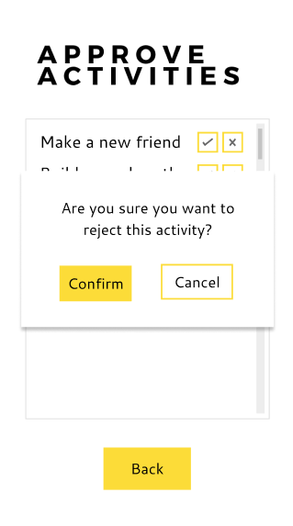

|  |  |  |
| --- | --- | --- |
| **Use Case ID** | **Use Case Name** | |
| A0300 | Allocate Activity Points | |
| **Primary Business Actors** | | **Other participating Actors** |
| Admin | |  |
| **Description** | Admin allocates points to suggested activities. | |
| **Pre-Conditions** | The Admin is logged in. | |
| **Triggers** | Called by A0200. | |
| **Post-Conditions** | Points are allocated to an activity. | |
| **Basic Flow of Events** | 1. The system displays a form, including the activity details and a field for the Admin to enter the points amount. Options “Save” and “Cancel” are available. 2. Admin enters the points to be allocated to the activity. 3. Admin selects “Save”. 4. The system displays a confirmation message of the points amount with options “Confirm” and “Cancel”. 5. Admin selects “Confirm”. 6. Return to A0200. | |
| **Alternate Flow of Events** | 3. Admin selects “Cancel”.  4. Return to Basic Flow step 6. | |
| **Alternate Flow of Events** | 5. Admin selects “Cancel”.  6. Return to Basic Flow step 1. | |
| **Initial UI design** | [See below] | |

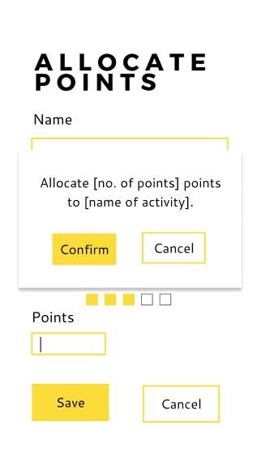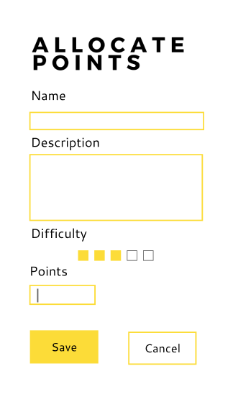

|  |  |  |
| --- | --- | --- |
| **Use Case ID** | **Use Case Name** | |
| A0400 | Suggest Activity | |
| **Primary Business Actors** | | **Other participating Actors** |
| Sponsor, User | | Admin |
| **Description** | Users or Sponsors may suggest a new activity along with all its details, which may either be private or publicly available to other users. The activity will thereafter be sent for administrator approval. | |
| **Pre-Conditions** | User/Sponsor must have an account. | |
| **Triggers** | User/Sponsor selects “Suggest Activity” option on their home page. | |
| **Post-Conditions** | An activity will be submitted for administrator approval. Admin is notified of suggested activity submission. | |
| **Basic Flow of Events** | 1. An activity details form with “Submit” and “Cancel” buttons is displayed. 2. User inputs activity name, along with other details, including a brief description, estimated difficulty level and whether the activity is public or private. 3. User selects “Submit”. 4. A confirmation message appears for the user to “Confirm” or “Cancel” the submission. 5. User selects “Confirm”. 6. A message confirms that the activity suggestion has been submitted. A0500 is called at this point. 7. Home screen is displayed. | |
| **Alternate Flow of Events** | 1. User selects “Cancel”. 2. Return to Basic Flow step 7. | |
| **Alternate Flow of Events** | 1. User selects “Cancel”. 2. Return to Basic Flow step 2. | |
| **Initial UI design** | [See below] | |



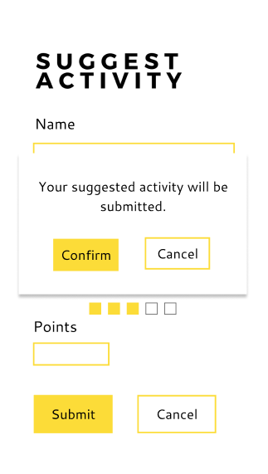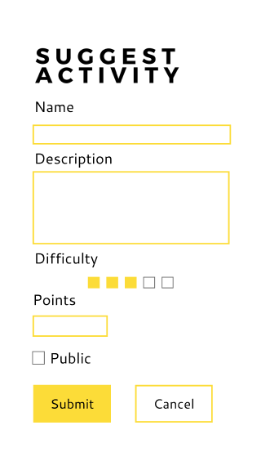

|  |  |  |
| --- | --- | --- |
| **Use Case ID** | **Use Case Name** | |
| A0500 | Notify Admin of Suggested Activity | |
| **Primary Business Actors** | | **Other participating Actors** |
|  | | Admin |
| **Description** | The system sends a notification to the administrator that a new activity has been suggested and requires approval. | |
| **Pre-Conditions** | An activity must have been suggested by a user/sponsor. | |
| **Triggers** | Called by A0400 once an activity suggestion has been submitted. | |
| **Post-Conditions** | The administrator receives a notification of an activity suggestion. | |
| **Basic Flow of Events** | 1. A message is sent to the Admin to say that a new activity has been suggested and requires approval. | |
| **Initial UI design** | [See below] | |

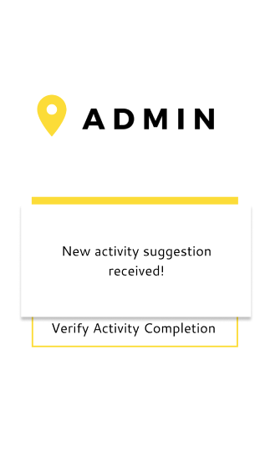

### Designed by Kristin Giddy

|  |  |  |
| --- | --- | --- |
| **Use Case ID** | **Use Case Name** | |
| B0100 | Create Bucket List | |
| **Primary Business Actors** | | **Other participating Actors** |
| User | |  |
| **Description** | Users can create a new bucket list to which they will be able to add activities to complete. | |
| **Pre-Conditions** | The user must have an account. | |
| **Triggers** | The user selects the “Create Bucket List” option from the home screen. | |
| **Post-Conditions** | A new empty bucket list is set up and available for the user to add activities. | |
| **Basic Flow of Events** | 1. A bucket list creation form is displayed. 2. User inputs name of bucket list. 3. User selects “Save” option. 4. A message is displayed to confirm the bucket list creation along with buttons “Add now” to add activities immediately, and “Later” to add activities at a later stage. 5. User selects “Later” option. 6. User’s home screen is displayed. | |
| **Alternate Flow of Events** | 1. User selects “Add now” option. 2. Calls B0200. 3. Return to Basic Flow step 6. | |
| **Initial UI design** | [See below] | |

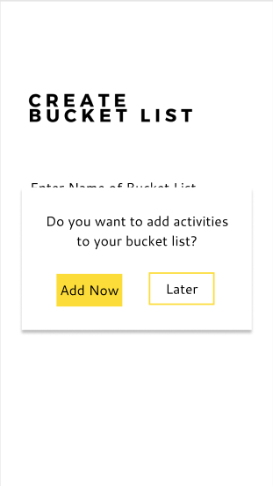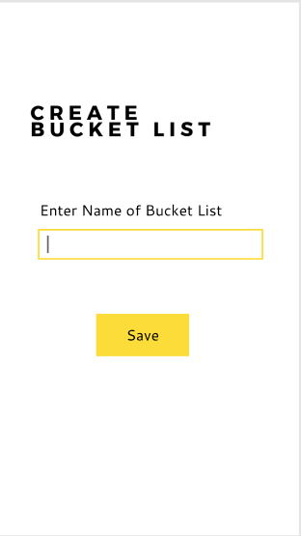

|  |  |  |
| --- | --- | --- |
| **Use Case ID** | **Use Case Name** | |
| B0200 | Add Activity to Bucket List | |
| **Primary Business Actors** | | **Other participating Actors** |
| User | |  |
| **Description** | The user can add an activity to one of the bucket lists. | |
| **Pre-Conditions** | The user must have created at least one bucket list. | |
| **Triggers** | User selects “Add Activity” option of a bucket list. Or called by B0100. | |
| **Post-Conditions** | An activity is added to the user’s chosen bucket list, which they may subsequently complete. | |
| **Basic Flow of Events** | 1. The system displays a list of all available public activities, with an “Add”/(+) button alongside each activity. Option to go “Back” is available. 2. The user selects the “Add” button on an activity. 3. The system adds the activity to the bucket list of the user. | |
| **Alternate Flow of Events** | 2. The user selects the “Back” button.  3. User home page is displayed. A | |
| **Initial UI design** | [See below] | |

When a bucket list is selected from the user home page, options for that bucket list become available.

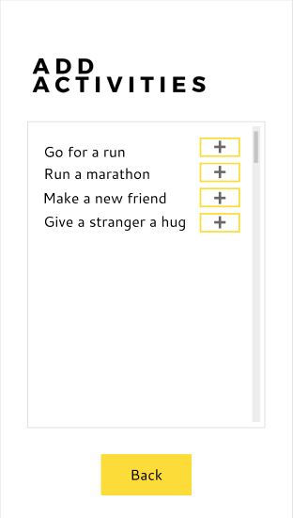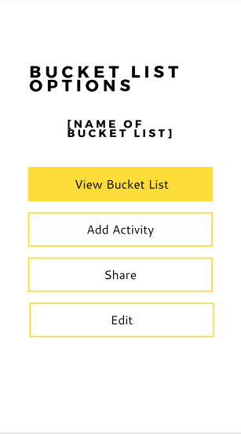

|  |  |  |
| --- | --- | --- |
| **Use Case ID** | **Use Case Name** | |
| B0300 | Share Bucket List | |
| **Primary Business Actors** | | **Other participating Actors** |
| User | |  |
| **Description** | A user may share a bucket list with other users (friends), allowing the users to complete the activities thereon collaboratively. | |
| **Pre-Conditions** | The user must have a least one bucket list containing at least one activity. | |
| **Triggers** | The user selects the “Share” option of a specific bucket list. | |
| **Post-Conditions** | Other chosen users may access the user’s shared bucket list and collaborate to complete the activities it contains. | |
| **Basic Flow of Events** | 1. The user’s friends are displayed. 2. A message prompts the user to select the friends with whom to share the bucket list and there are two buttons, “Confirm” and “Cancel”. 3. The user selects friends from the list. 4. User selects “Confirm”. 5. A message is displayed to confirm that the bucket list is now shared. 6. The user’s home screen is displayed. | |
| **Alternate Flow of Events** | 1. User selects “Cancel”. 2. A message is displayed to indicate that the bucket list has not been shared. 3. Return to Basic Flow step 6. | |
| **Initial UI design** | [See below] | |

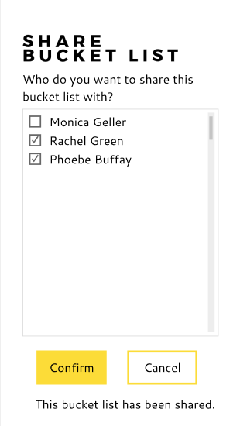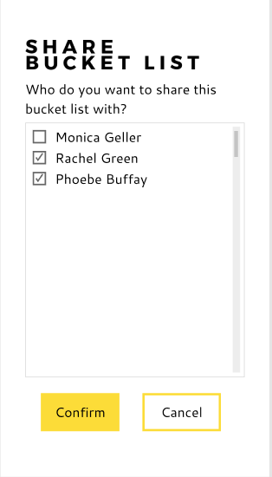

|  |  |  |
| --- | --- | --- |
| **Use Case ID** | **Use Case Name** | |
| B0400 | Manage Bucket List | |
| **Primary Business Actors** | | **Other participating Actors** |
| User | |  |
| **Description** | A user may remove activities from a bucket list or delete a bucket list. | |
| **Pre-Conditions** | The user must have at least one bucket list and, if removing activities, the bucket list must contain at least one activity. | |
| **Triggers** | User selects “Edit” option for a specific bucket list. | |
| **Post-Conditions** | The bucket list either has fewer activities or has been removed. | |
| **Basic Flow of Events** | 1. The bucket list and its activities are displayed, along with options “Remove Activity”/ (“-”) , “Delete Bucket List” and “Done”. 2. User selects the “Remove Activity” /(“-”) button for a specific activity. 3. A confirmation message appears asking the user to either confirm or cancel the removal. 4. User selects “Confirm”. 5. The refreshed bucket list is displayed. 6. The user may continue editing or return to the home screen. 7. User selects ”Done”. 8. The user’s home screen is displayed. | |
| **Alternative Flow of Events** | 1. User selects “Delete Bucket List” option. 2. A confirmation message appears asking the user to either confirm or cancel the deletion. 3. User selects “Confirm”.   4.1. User selects “Cancel”  4.2. Return to Basic Flow step 1.   1. The bucket list is removed from the database. 2. The system displays a confirmation message saying the bucket list has been successfully deleted as well as an “OK” button. 3. The user selects “OK”. 4. Return to Basic Flow step 8. | |
| **Alternate Flow of Events** | 1. User selects “Done”. 2. Return to Basic Flow step 8. | |
| **Alternative Flow of Events** | 1. User selects “Cancel”. 2. Return to Basic Flow step 6. | |
| **Initial UI design** | [See below] | |

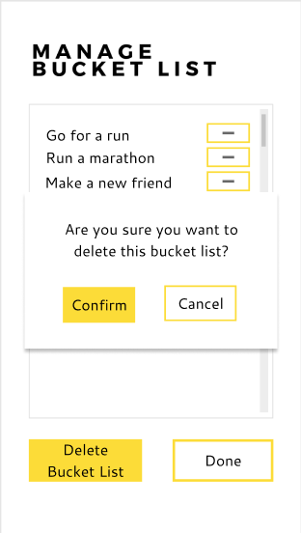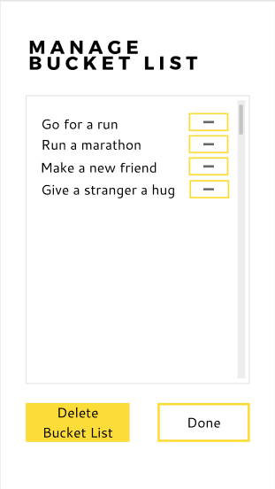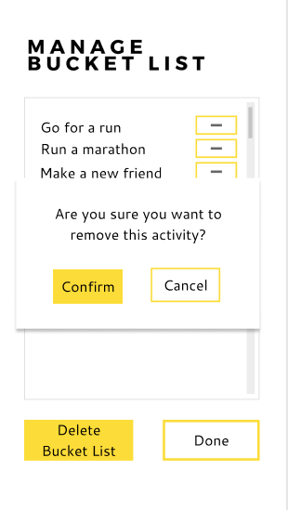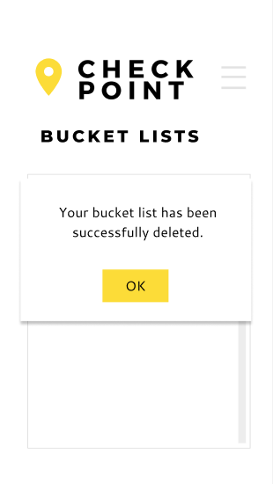

|  |  |  |
| --- | --- | --- |
| **Use Case ID** | **Use Case Name** | |
| B0500 | View Personal Bucket List | |
| **Primary Business Actors** | | **Other participating Actors** |
| User | |  |
| **Description** | A user may view the contents of a specific bucket list belonging to that user. | |
| **Pre-Conditions** | User must have at least one bucket list. | |
| **Triggers** | User selects the “View Bucket List” option for a specific bucket list. | |
| **Post-Conditions** | The bucket list and all activities it contains are displayed. | |
| **Basic Flow of Events** | 1. The bucket list title and the names of all the activities it contains are displayed, with options to view the details of a specific activity, filter the list, or return to the home screen. 2. User selects “View Details”/(three dots) option for an activity. 3. Calls B0800. 4. Once the called use case has been completed, user may select another option. 5. User selects “Return Home” option. 6. The user’s home screen is displayed. | |
| **Alternate Flow of Events** | 1. User selects “Filter List” option. 2. Calls B0700. 3. Return to Basic Flow step 4. | |
| **Alternate Flow of Events** | 1. User selects “Return Home” option. 2. Return to Basic Flow step 6. | |
| **Initial UI design** | [See below] | |

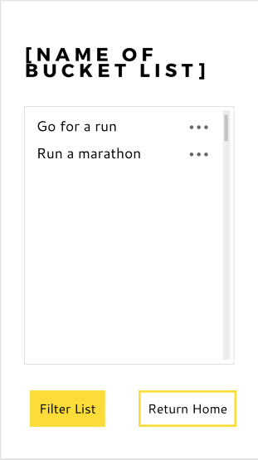

|  |  |  |
| --- | --- | --- |
| **Use Case ID** | **Use Case Name** | |
| B0600 | View Public Activities | |
| **Primary Business Actors** | | **Other participating Actors** |
| User | |  |
| **Description** | All available public activities which a user may complete are displayed. | |
| **Pre-Conditions** | A user must have an account. | |
| **Triggers** | User selects “View Public Activities” option on home page. | |
| **Post-Conditions** | All public activities are displayed as a list for the user to see. | |
| **Basic Flow of Events** | 1. The names of all public activities are displayed, with options to view the details of a specific activity, filter the list, or return to the home screen. 2. User selects “View Details”/(three dots) option for an activity. 3. Calls B0800. 4. Once the called use case has been completed, user may select another option. 5. User selects “Return Home” option. 6. The user’s home screen is displayed. | |
| **Alternate Flow of Events** | 1. User selects “Filter List” option. 2. Calls B0700. 3. Return to Basic Flow step 4. | |
| **Alternate Flow of Events** | 1. User selects “Return Home” option. 2. Return to Basic Flow step 6. | |
| **Initial UI design** | [See below] | |

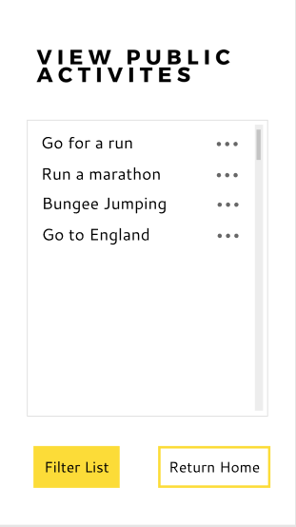

|  |  |  |
| --- | --- | --- |
| **Use Case ID** | **Use Case Name** | |
| B0700 | Filter Activities | |
| **Primary Business Actors** | | **Other participating Actors** |
| User | |  |
| **Description** | The user may choose a method by which to filter the list of activities which they are viewing, i.e. according to name, difficulty or points. | |
| **Pre-Conditions** | The user must be viewing either a bucket list and its activities or the list of public activities. | |
| **Triggers** | User selects “Filter List” option while viewing a list of activities. | |
| **Post-Conditions** | The activities list is redisplayed according the applied filter. | |
| **Basic Flow of Events** | 1. Options on how to filter the list are displayed (i.e. by name, difficulty or points). 2. User selects the desired filter. 3. The list of activities is filtered by the system. 4. The activities list is redisplayed with the desired filter applied. 5. Return to calling use case. | |
| **Initial UI design** | [See below] | |

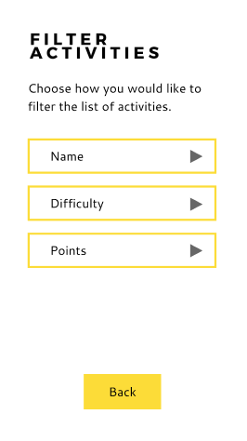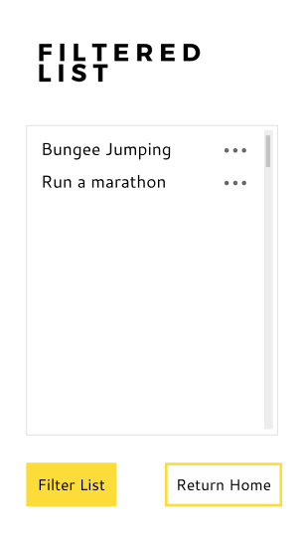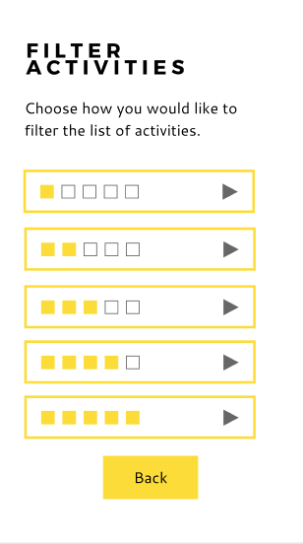

|  |  |  |
| --- | --- | --- |
| **Use Case ID** | **Use Case Name** | |
| B0800 | View Activity Details | |
| **Primary Business Actors** | | **Other participating Actors** |
| User | |  |
| **Description** | All the details of a specific activity are displayed for the user. | |
| **Pre-Conditions** | The user must be viewing either a bucket list and its activities or the list of public activities. | |
| **Triggers** | User selects “View Details”/three dots option for a specific activity while viewing a list of activities. | |
| **Post-Conditions** | The full details of the corresponding activity are displayed. | |
| **Basic Flow of Events** | 1. Each detail of the chosen activity is displayed, i.e. name, description, difficulty and points. A “Back” button allows the user to return the list. 2. After viewing the details, the user selects the “Back” option. 3. Returns to calling use case. | |
| **Initial UI design** | [See below] | |

Example of where “View details”/Three dots option chosen where activities are displayed.

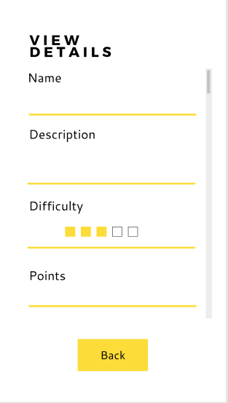

### Designed by Claire Bodley

|  |  |  |
| --- | --- | --- |
| **Use Case ID** | **Use Case Name** | |
| C0100 | Complete Activity | |
| **Primary Business Actors** | | **Other participating Actors** |
| User | | Admin |
| **Description** | To complete an activity and acquire activity points, the user should submit a photo or unique code. | |
| **Pre-Conditions** | The user should have a bucket list, populated with at least one activity. | |
| **Triggers** | The user selects the option to “Complete Activity” within the user home page. | |
| **Post-Conditions** | In the case of a verification code, an activity verification code is saved onto the database and awaits verification from a sponsor. Where Photo/Video evidence is submitted, the admin is notified of activity completion. | |
| **Basic Flow of Events** | 1. System displays options “Verification Code”, “Photo/Video” and “Cancel”. 2. User selects “Verification Code”. 3. System displays a verification code placeholder for the user to complete, as well as options “Back” and “Confirm”. 4. User enters the sponsor verification code into the placeholder. 5. User selects “Confirm”. 6. The system saves the verification code in the CheckPoint database. 7. Confirmation message is displayed as well as a “Return to home page” option. 8. User selects “Return to home page”. 9. Return to user home page. | |
| **Alternate Flow of Events** | 2. User selects “Photo/Video” option.  3. System opens the user’s gallery. A “Back” option is available.  3.1. The “Back” option is selected.  3.2. Return to Basic Flow step 1.  4. User selects the required photo/video from the gallery.  5. System displays photo/video selected as well as options “Confirm” and “Back”.  6. User selects “Confirm”.  6.1. User selects “Back”.  6.2. Return to step 3.  7. System sends activity evidence through to Admin for verification. System displays confirmation message as well as a “Back to home page” option.  8. User selects “Back to home page”.  9.Return to Basic Flow step 9. | |
| **Alternate Flow of Events** | 2. User selects “Cancel”.  3. Return to Basic Flow step 9. | |
| **Alternate Flow of Events** | 5. User selects “Back”.  4. Return to Basic Flow step 1. | |
| **Initial UI design** | [See below] | |

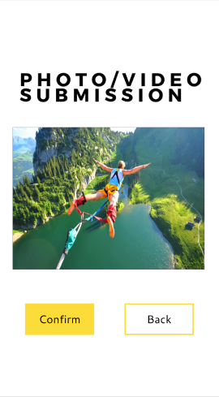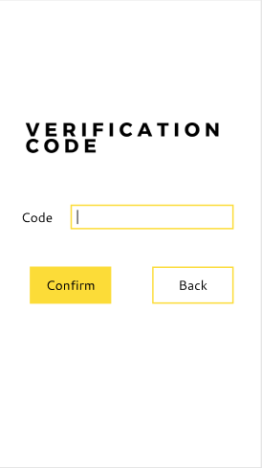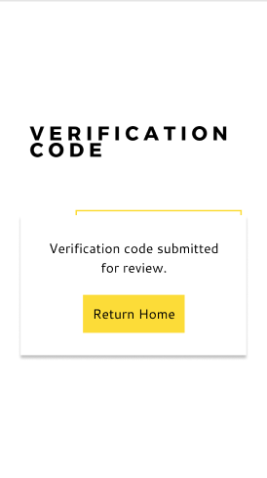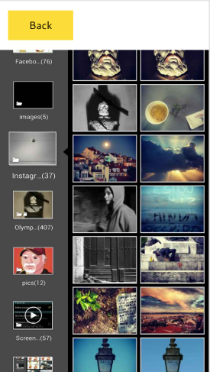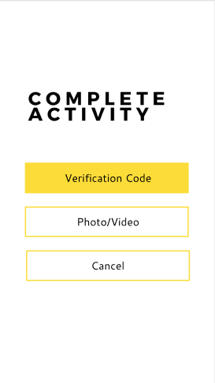

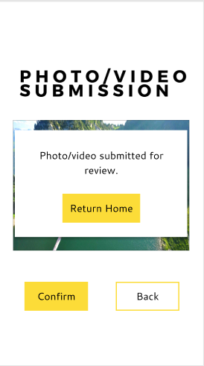

|  |  |  |
| --- | --- | --- |
| **Use Case ID** | **Use Case Name** | |
| C0200 | Verify Activity Completion | |
| **Primary Business Actors** | | **Other participating Actors** |
| Admin, Sponsor | | User |
| **Description** | Admin receives evidence of activity completion and should reject or verify completion of that activity. A sponsor verifies an activity by providing an activity completion code. Once this code has been entered, all users who have used this code to complete an activity, will be awarded points. Once an activity has been verified, points are awarded to the user. | |
| **Pre-Conditions** | Admin has received notification of evidence that a user has completed an activity. Sponsor has shared the verification code with users who have completed their activity. | |
| **Triggers** | Admin/sponsor selects “Verify Activity Completion” within the admin/sponsor home page. | |
| **Post-Conditions** | Activity evidence/verification code is either accepted, in which case points are allocated to a user, or rejected, in which case no points are allocated. | |
| **Basic Flow of Events** | 1. In the case where the actor is an admin, the system displays a list of users who have requested activity verification. Alongside their usernames, option “View Evidence” is displayed. Option “Back” is available. 2. Admin selects “View”. 3. The system displays the Photo/Video evidence submitted by a user as well as options “Verify” and “Reject”. 4. Admin selects “Verify”. 5. Calls C0300. 6. Return to step 1. | |
| **Alternate Flow of Events** | 1. In the case where the actor is a sponsor, the system displays a verification code placeholder for the sponsor to complete as well as options “Confirm” and “Back”. 2. The sponsor enters the activity verification code. 3. The sponsor selects “Confirm”. 4. The sponsor selects “Back” 5. Return to sponsor home page. 6. The activity verification code is added to the database. 7. All users with the activity verification code that matches the code of the sponsor, are awarded points. C0300 is called at this stage. 8. The system displays a confirmation message as well as option “OK”. 9. Sponsor selects “OK”. 10. Return to sponsor home page. | |
| **Alternate Flow of Events** | 2. Admin selects “Back”.  3. Return to admin home page. | |
| **Alternate Flow of Events** | 1. Admin selects “Reject”. 2. Return to Basic Flow step 1. | |
| **Initial UI design** | [See below] | |

Where the actor is admin:

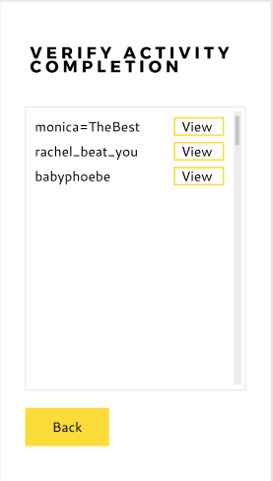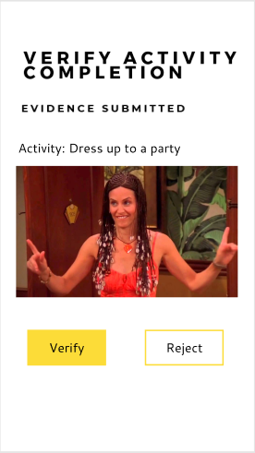

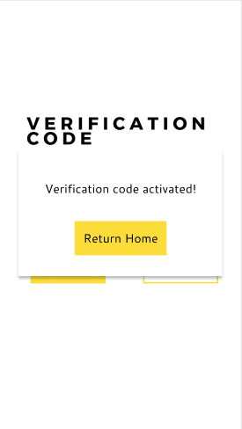Where the actor is a sponsor:

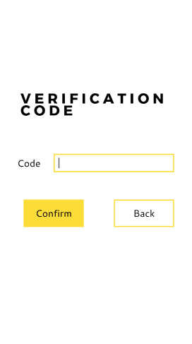

|  |  |  |
| --- | --- | --- |
| **Use Case ID** | **Use Case Name** | |
| C0300 | Award Points | |
| **Primary Business Actors** | | **Other participating Actors** |
|  | |  |
| **Description** | Once activity completion has been verified, points are awarded to the user, whereby the user’s points balance is updated by adding the specified number of points. | |
| **Pre-Conditions** | C0200 has taken place. | |
| **Triggers** | Called by C0200. | |
| **Post-Conditions** | The activity points are added and allocated to the user’s points balance. | |
| **Basic Flow of Events** | 1. The system extracts the points to be allocated from the activity information and adds it to the user’s points balance. 2. The system displays confirmation message and the user’s new points balance as well as an “OK” button. 3. The user selects “OK”. | |
| **Initial UI design** | [See below] | |

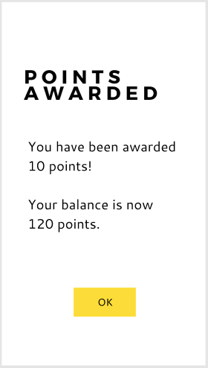

### Designed by James Shepherd

|  |  |  |
| --- | --- | --- |
| **Use Case ID** | **Use Case Name** | |
| D0100 | Register as User | |
| **Primary Business Actors** | | **Other participating Actors** |
| User | |  |
| **Description** | Enables a person to create an account on CheckPoint, in order to use the functionalities of a user. | |
| **Pre-Conditions** | App must have been downloaded. | |
| **Triggers** | Person selects “Register as User” on CheckPoint home page. | |
| **Post-Conditions** | Person is registered as a user and can make use of the CheckPoint ‘User’ functionalities. | |
| **Basic Flow of Events** | 1. System displays a form, with all necessary user information as well as options “Register” and “Cancel”. 2. User completes the form. 3. User selects “Register”. 4. The system adds the new user to the CheckPoint database and displays the user home page. | |
| **Alternate Flow of Events** | 1. User selects “Cancel”. 2. Return to CheckPoint home page. | |
| **Initial UI design** | [See below] | |

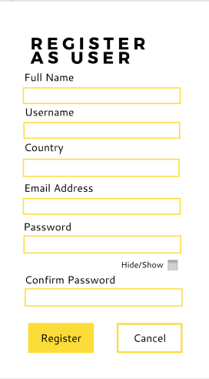

|  |  |  |
| --- | --- | --- |
| **Use Case ID** | **Use Case Name** | |
| D0200 | Register as Sponsor | |
| **Primary Business Actors** | | **Other participating Actors** |
| Sponsor | |  |
| **Description** | Enables a company to create an account on CheckPoint in order to use the functionalities of a sponsor. | |
| **Pre-Conditions** | App must have been downloaded. | |
| **Triggers** | Company selects “Register as Sponsor” on CheckPoint home page. | |
| **Post-Conditions** | Company is registered as a sponsor and can make use of the CheckPoint ‘Sponsor’ functionalities. | |
| **Basic Flow of Events** | 1. System displays a form, with all necessary sponsor information as well as options “Register” and “Cancel”. 2. Sponsor completes the form. 3. Sponsor selects “Register”. 4. The system adds the new sponsor to the CheckPoint database and displays the sponsor home page. | |
| **Alternate Flow of Events** | 3. User selects “Cancel”.  4. Return to CheckPoint home page. | |
| **Initial UI design** | [See below] | |

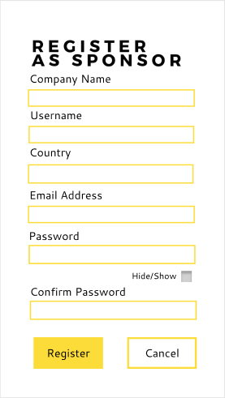

|  |  |  |
| --- | --- | --- |
| **Use Case ID** | **Use Case Name** | |
| D0300 | Add Friend | |
| **Primary Business Actors** | | **Other participating Actors** |
| User | |  |
| **Description** | A user adds another user as a ‘Friend’. This enables the user to use friend functionalities. | |
| **Pre-Conditions** | The user is registered. | |
| **Triggers** | The user selects “Add Friend” option within the user home page. | |
| **Post-Conditions** | The user has a new friend. | |
| **Basic Flow of Events** | 1. The system displays a name placeholder for which the user can use to search for a friend as well as options “Search” and “Cancel”. 2. The user enters the username of another user within the placeholder. 3. The user selects “Search”. 4. The system searches the database for a user with the username entered by the user. 5. A user with that username is found and displayed, as well as an option to “Friend”. 6. The user selects the option “Friend”. 7. The system creates a friend relationship between the two users and displays a confirmation message with option “OK”. 8. User selects “OK”. 9. Return to step 1. | |
| **Alternate Flow of Events** | 1. User selects “Cancel”. 2. Return to user home page. | |
| **Alternate Flow of Events** | 1. A user with that username is not found by the system. The system displays a message saying that the username does not exist as well as an “OK” button. 2. The user selects “OK”. 3. Return to Basic Flow step 1. | |
| **Initial UI design** | [See below] | |

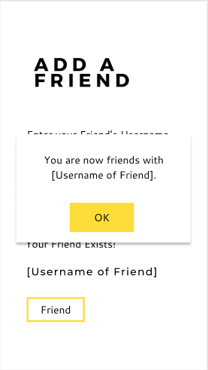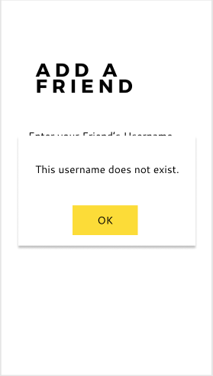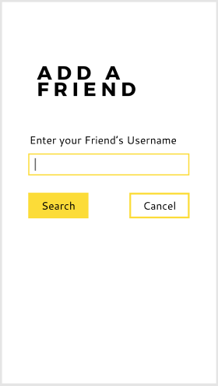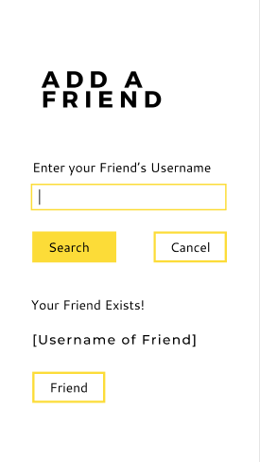

|  |  |  |
| --- | --- | --- |
| **Use Case ID** | **Use Case Name** | |
| D0400 | Manage Account | |
| **Primary Business Actors** | | **Other participating Actors** |
| User, Admin, Sponsor | |  |
| **Description** | Enables user/admin/sponsor to update account details or delete their account. | |
| **Pre-Conditions** | User/admin/sponsor is registered. | |
| **Triggers** | User/admin/sponsor selects “Manage Account” from the home page. | |
| **Post-Conditions** | User/admin/sponsor account is updated or deleted. | |
| **Basic Flow of Events** | 1. System displays options “Update Account”, “Delete Account” and “Back”. 2. Actor selects “Update Account”. 3. The system displays all actor information on a form as well as options “Save” and “Cancel”. 4. Actor edits the fields on the form to update details. 5. Actor selects “Save”. 6. The system updates all fields changed by actor and displays confirmation message and option “OK”. 7. Actor selects “OK”. 8. Return to actor home page. | |
| **Alternate Flow of Events** | 2. Actor selects “Delete Account”.  3. System displays confirmation message as well as options “Delete” and “Cancel”.  4. Actor selects “Delete”.  4.1. Actor selects “Cancel”.  4.2. Return to Basic Flow step 1.  5. The system deletes all actor account information and displays deletion message.   1. Return to CheckPoint home page. | |
| **Alternate Flow of Events** | 2. Actor selects “Back”.  3. Return to Basic Flow step 8. | |
| **Alternate Flow of Events** | 5. Actor selects “Cancel”.  6. Return to Basic Flow step 1. | |
| **Initial UI design** | [See below] | |

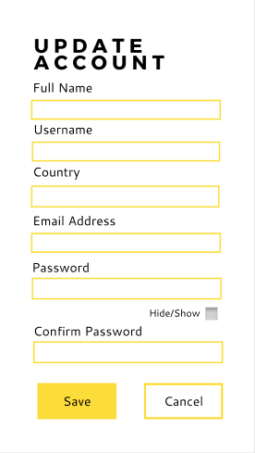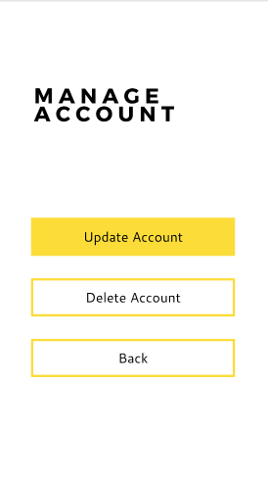

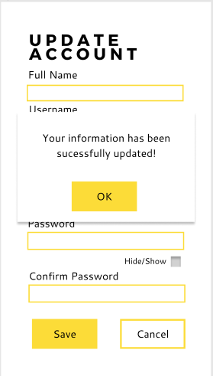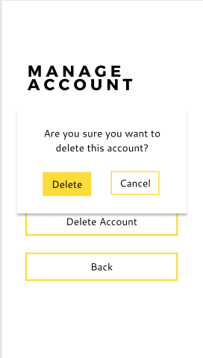

# DATA REQUIREMENTS

## 3.1 Domain Class Diagram

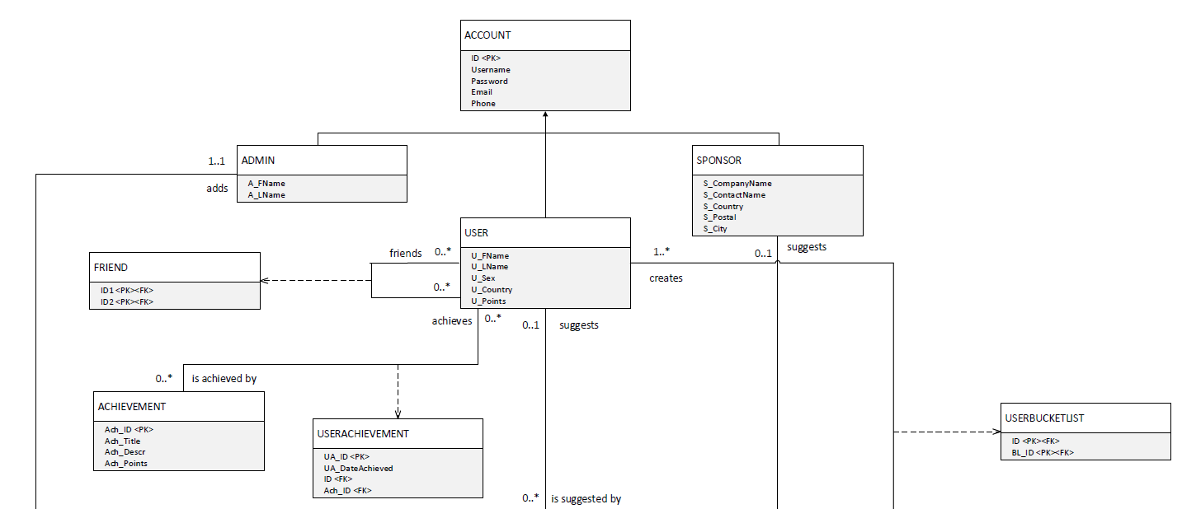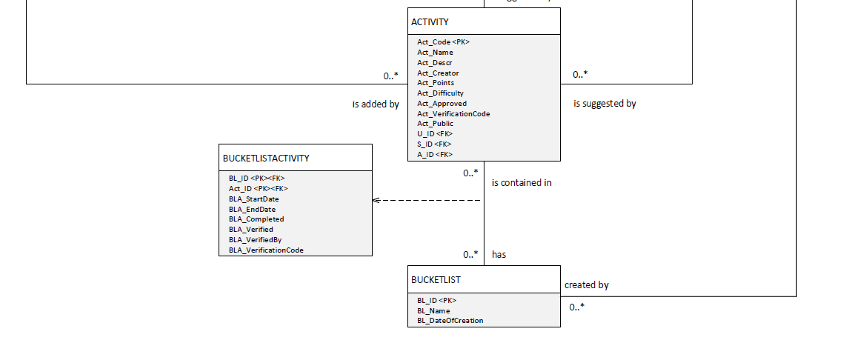

## Implementation Ready Class Diagram

Notes on implementation diagram:

Inheritance is mapped for design by implementing only the subclasses as tables. This is because the superclass ‘Account’ is abstract and no instances of it exist.

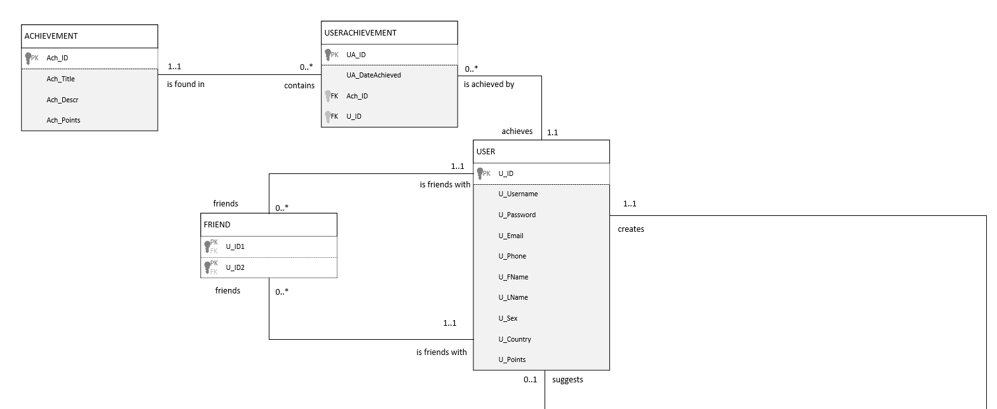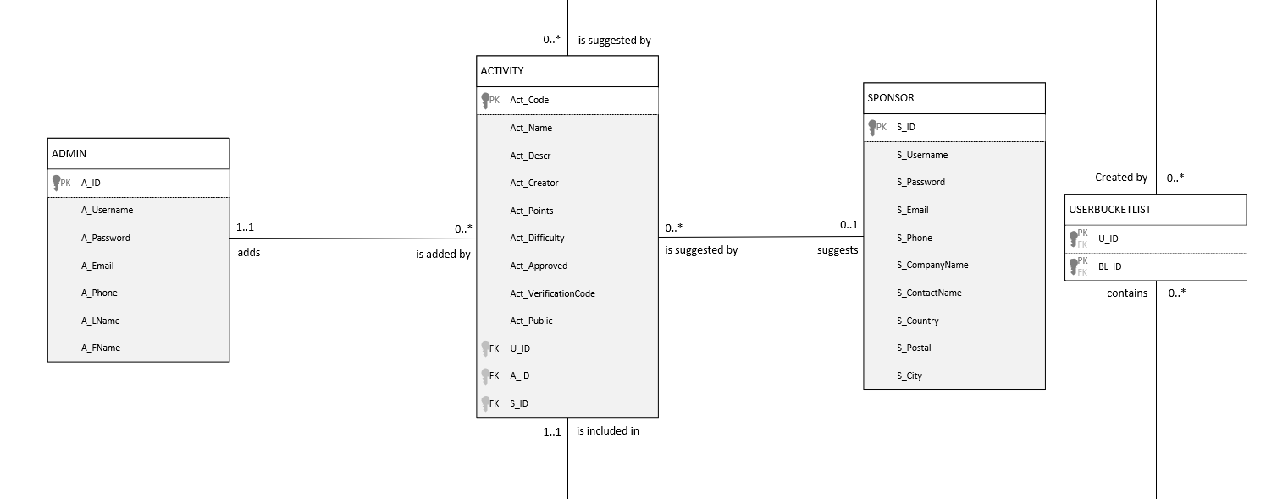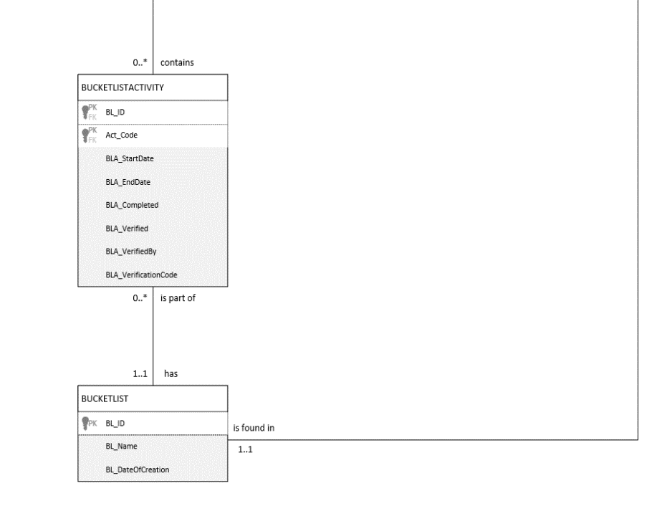

**Department of Computing Sciences**

**Plagiarism Declaration - Elaboration Document**

**Module code:** WRRV301

**We,**

|  |  |  |
| --- | --- | --- |
| **Name** | **Student Number** | **Contribution % [Total = 100]** |
| Claire Bodley | 216442656 | 25% |
| Carmel Chan-Lok | 217143903 | 25% |
| Kristin Giddy | 217103413 | 25% |
| James Shepherd | 217257968 | 25% |

**hereby declare that this submission is our own, original work.**

We further declare that:

1. No part of this submission has been copied from another person/group,

2. We **did not** work with another person/group on this submission,

3. We acknowledged all consulted sources in the text and submitted a list of references, and

4. Parts without references are entirely our own work

5. That we have all equally contribute to the work or as indiciated in the contribution % above.

We understand that, should this declaration be false, we may be charged with academic misconduct and/or plagiarism and that a disciplinary hearing may be brought against us.

1. SIGNED: ............................................... DATE ...............................................
2. SIGNED: ............................................... DATE ...............................................
3. SIGNED: ............................................... DATE ...............................................
4. SIGNED: ............................................... DATE ...............................................